Nepal College of Information Technology
Unit Test
Fall 2009

Program: BE Time: 2 hrs
Semester: VII FM: 55
Subject: Data Warehousing and Data Mining PM:
Attempt ALL the questions. Figures at the margin indicate their full marks.
 | (a) | Define Data Warehouse in detail. Also give a brief comparison between OLTP and OLAP. |  | 8
 | (b) | What is an OLAP engine? Discuss ROLAP in detail. |  | 7
 | (a) | What do you understand by Dimension Modeling and Lattice of Cuboid? |  | 5
 | (b) | Given a sample data cube below, solve the problems given below.  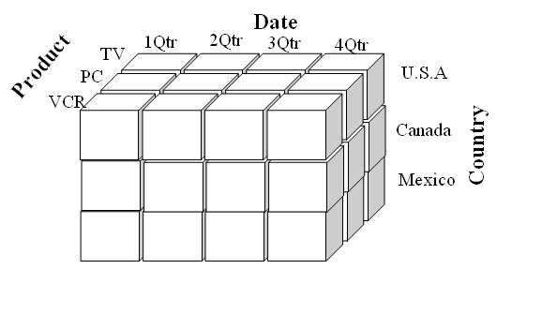  Draw Star schema, and Snowflakes schema corresponding to the data cube given above. Snowflakes schema should represent the same attributes as in the Star schema.  Also define the cube and dimensions using DMQL for both star and snowflakes schema.  Note: Assume attributes for each dimensions. Take Summary measures as, Units_Sold, and Rupees_Sold.  You can assume data as required. |  | 10
 | (a) | Illustrate Data Warehouse architecture. Discuss about Meta data in detail. | 8
 | (b) | What is Knowledge Discovery in Database (KDD)? Explain the KDD process in detail. | 7
 | Write short notes on (any TWO) 2*5 = |  | 10
 | (a) | Cube Operations
 | (b) | MOLAP
 | (c) | Fact Constellation

